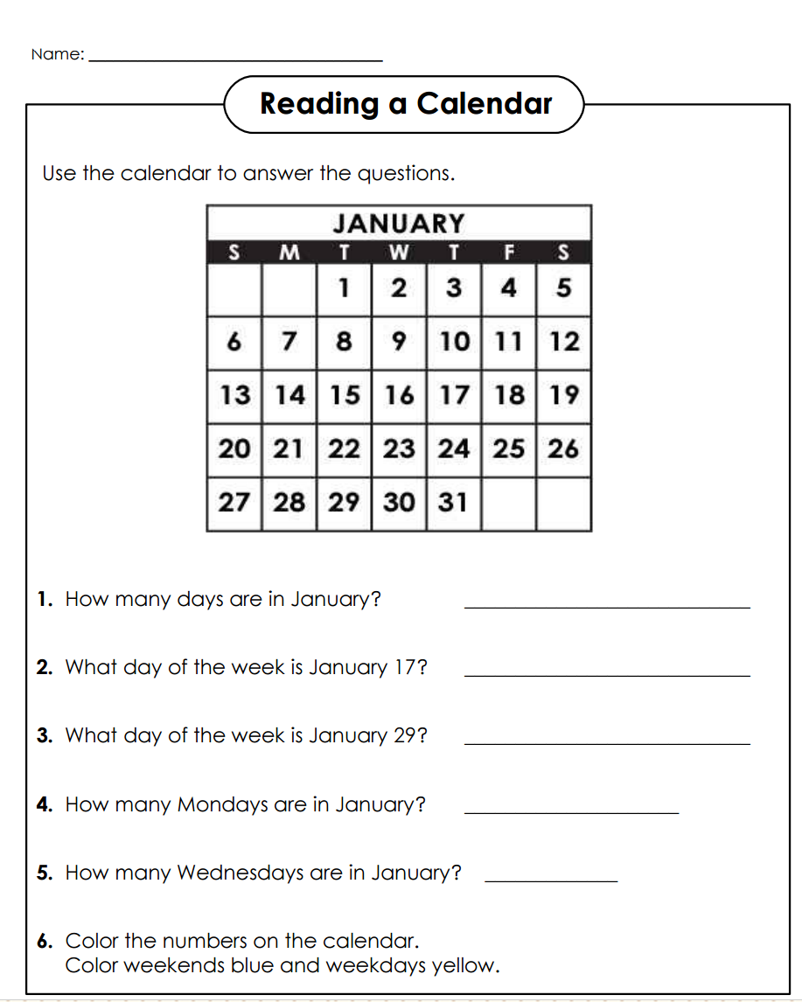

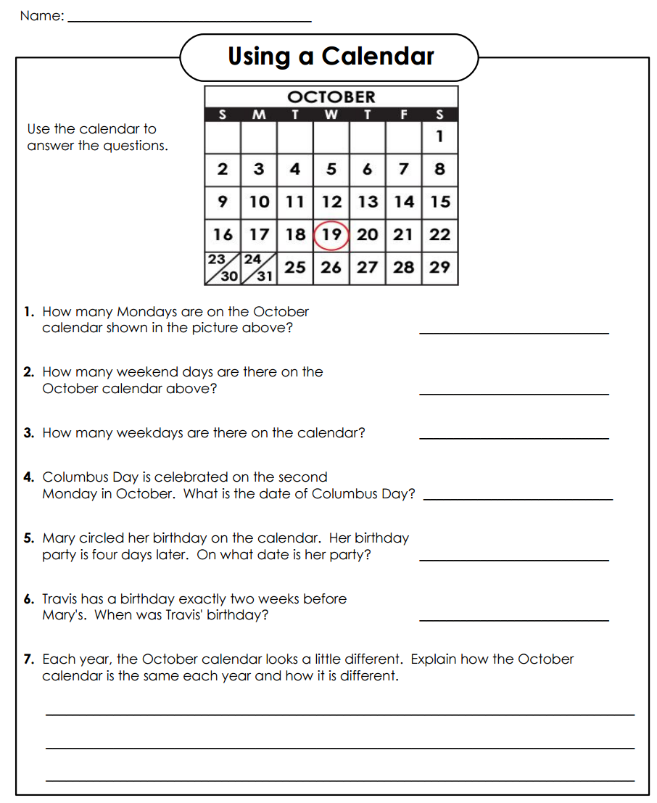
Reading a Calendar
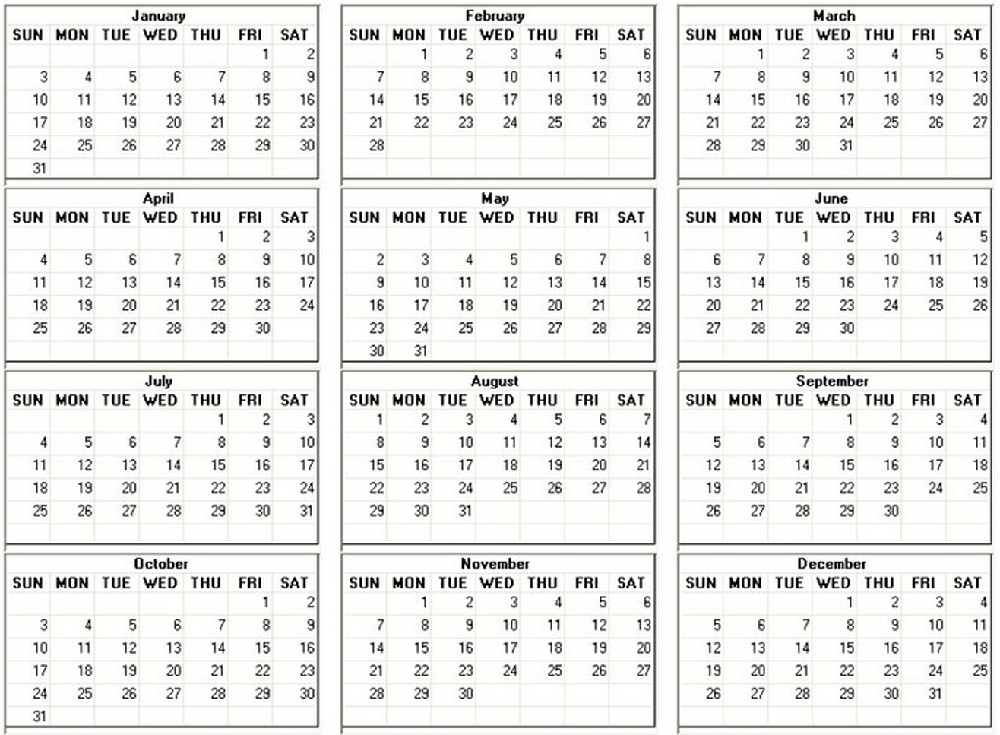
Use the following calendar to answer the questions below.
- List all the month that has 31 days.

- Mark's birthday is on March 24. His party is exactly two weeks later. What is the date of his party?

- What day of the week is New Year’s Day (January 1st)?

- Mother's Day is on the second Sunday in May. On the calendar above, what is the date of Mother's Day?

- What is a leap year? Is the year shown on the calendar a leap year? Explain how you know.

