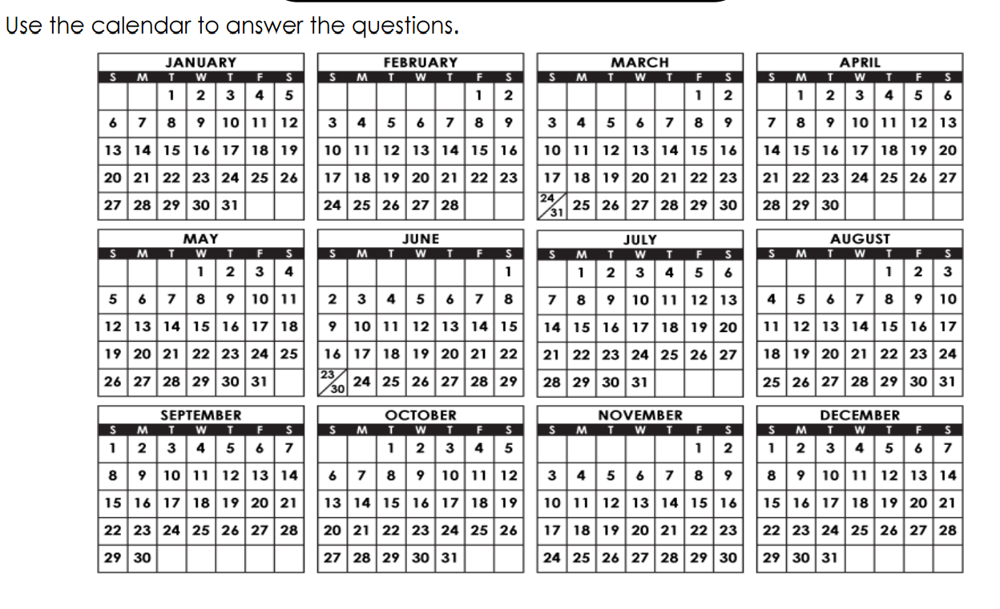
Reading a Calendar
- Are there more months with exactly 30 days or 31 days?

- Mark's birthday is on March 24. His party is exactly two weeks later. What is the date of his party?

- What day of the week does New Year’s Day fall?

- Mother's Day falls on the second Sunday in May. On the calendar above, what is the date of Mother's Day?

- Is the year shown on the calendar a leap year? Explain how you know.

